# Resisters

The relationship between the current and the voltage for a resister is linear and is called Ohms Law. This relationship is in terms of the resistance. A unit of resistance is called an Ohm.

|  |  |  |
| --- | --- | --- |
|  |  |  |

Resisters in sequence and in parallel can be combined to form a single equivalent resister as follows:

|  |  |  |
| --- | --- | --- |
|  |  |  |
|  |  |  |

# Solving Circuits

We can use Ohms Law to solve simple circuits.

**Example**: We can use Ohm’s law to solve the following circuit.

|  |  |
| --- | --- |
|  |  |

For more complex circuits, we can solve circuits by combining resisters until there is only one left, then use Ohms Law to solve.

**Example**: Find Vo.

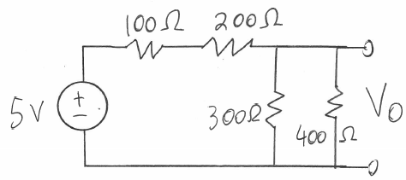

First combine the  with the  to get . Then combine the  with the  using the parallel equation to get . Then we have the following simplified circuit.

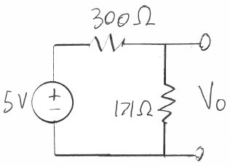

To solve we can find the equivalent resistance of  and use Ohms Law to get

.

Next use Ohms Law again to find the voltage .



# Kirchhoff’s Laws

Some circuits cannot be solved by combining resisters. We must then use Kirchhoff’s voltage or current laws.

Kirchhoff’s Voltage Law: The sum of the voltage along a closed loop must be zero.

Kirchhoff’s Current Law: The sum of the current entering or leaving a node must be zero.

**Example**: Solve using Kirchhoff’s current law. Assume .

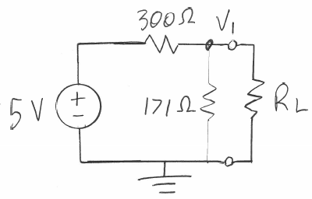

We sum all of the current leaving node V1 and equate to zero.



We simplify.



Move the constant to the other side.



Simplify.



Add the numbers and resolve the units. Note the units of volts over ohms is amps.



Then we get the voltage.



If we had two unknown voltages we would have ended up with two equations and two unknowns. We can put into matrix form and solve by taking the inverse of the matrix.

Power is the product of the current and the voltage.



Energy is the product of the power with time.



**Example**: A starter consumes 3600 watts of power to start. At 12 volts how much current does it need?







# Capacitors

The relationship between the current and the voltage for a capacitor is not linear. This relationship is in terms of the capacitance. A unit of capacitance is called a farad.

|  |  |  |
| --- | --- | --- |
|  |  |  |

Capacitors in sequence and in parallel can be combined to form a single equivalent capacitor as follows:

|  |  |  |
| --- | --- | --- |
|  |  |  |
|  |  |  |

# Indictors

The relationship between the current and the voltage for an inductor is not linear. This relationship is in terms of the inductance. A unit of inductance is a Henry.

|  |  |  |
| --- | --- | --- |
|  |  |  |

Capacitors in sequence and in parallel can be combined to form a single equivalent capacitor as follows:

|  |  |  |
| --- | --- | --- |
|  |  |  |
|  |  |  |

# Diodes

The relationship between the current and the voltage for a diode is best shown in a diagram.

|  |  |
| --- | --- |
|  |  |

The voltage drop across the diode in the forward direction is 0.7 volts. In the reverse direction the voltage drop depends on the designed value. They come in different values. Only zener type diodes are designed to be used with current flowing backwards. Diodes can be used as a one way street, as a light for light emitting diodes (LED) or as a current drain for ultra-fast acting diodes. Circuit design is easy as we assume a simple 0.7 voltage drop across the diode in the forward direction.

**Example**:

|  |  |  |
| --- | --- | --- |
|  |  | If  and then |

# NPN Transistors

The relationship between the current and the voltage for a bipolar junction transistor (BJT) is best shown in a diagram.

|  |  |
| --- | --- |
|  |  |

The voltage drop across the transistor between the collector and the emitter,, and the current passing between the collector and emitter, , depends on the current entering the base,  and on the transistor’s beta parameter, .

We can use a transistor as a switch by simply varying from to open the switch to a sufficient current to close the switch. In this function we only need one equation.



**Example**: Consider the following circuit:

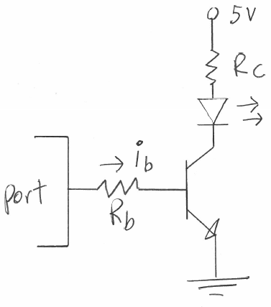

The LED turns on when the transistor conducts, that is when goes to ground (). We can turn the transistor on by applying a current to its base,. We need to calculate how much current we need to pass through the base to fully turn on the transistor. We use the transistor’s beta,  parameter to calculate this current. Assume the transistor is a 2N2222 which has a  of 100 and we want to pass 20mA across the LED when on. We wish to determine the value of the two resisters. We can design for the maximum current through the transistor and use  instead of . Then we use Ohms Law to calculate to produce a current of 20mA through the LED.





Next we calculate the value of by using Ohms Law.





If the load is larger than about 500mA (half an amp) then we need to use a power transistor and maybe a smaller transistor like the 2N2222 to feed the larger power transistor.

**Example**: Now consider a circuit to power a 2A motor at 12 volts. We need to use a power transistor. The TIP 31 can handle up to 3A and has a beta of 25. The input base current, , is greater than the 20mA the pin can source, so we will need the second stage of the amplifier.

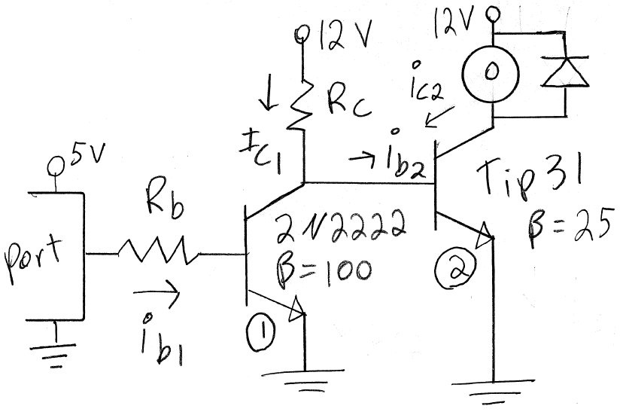

Since the beta parameter is not precise and even varies with temperature, we need to design a margin of error and will assume we need two times more current entering through the base as what our calculation give. So we will design with



Now we see that when the smaller transistor is off. So we have



Next we calculate the base current for the smaller transistor again using .



Now we can use Ohms Law and calculate the two resister values.



and



Note that when a transistor turns on, the voltage across the collector and emitter drops to zero. However in the smaller transistor the collector is tied to the base of the larger one and therefore this voltage cannot drop below 0.7V or the larger transistor will turn off. This is why we subtract 0.7V in calculating .

We have to watch out for heat dissipation when dealing with power transistors or small valued resisters. We can use the equation for power



To compute the heat dissipated through the device.

**Example**: For the previous example, the heat in and can be computed as follows:







Note is burning 1.8W which is much greater than the 0.25W maximum heat that device can dissipate. We can use a high heat power resister but those are hard to find, bulky, and expensive. Instead we can use two transistors in a Darlington Pair configuration. In this configuration, the current for the power transistor comes directly from a smaller transistor which takes the current directly from the collector of the larger one. Since it’s not coming from the 12V source, there is no need to reduce the voltage by burning it off in a resister. The power transistor will not be able to fully close and so it will need to dissipate heat. Power transistors are designed to dissipate heat well.

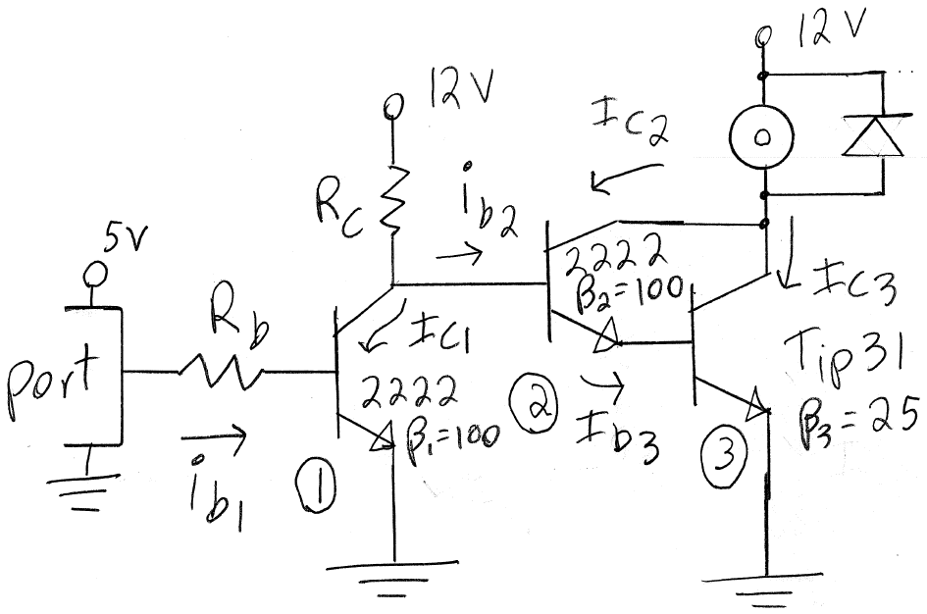

There is no need to bias the Darlington Pair and so again we only need to calculate and . We can treat the Darlington Pair as a power transistor with a large beta equal to the product of the two beta’s involved, 

**Example**: Use the Darlington Pair configuration for the same problem in the previous example.











Now we can use Ohms Law and calculate the two resister values.



and



To compute the power we have:







Note the power in each resister is less than 0.25W. However now the power in the transistor is greater. The transistor is designed to dissipate power and so it will work well.